**OOP Assignment # 2 GUI**

Some Picture of the output of Data Entry Form

1. This the output of Data Entry Form

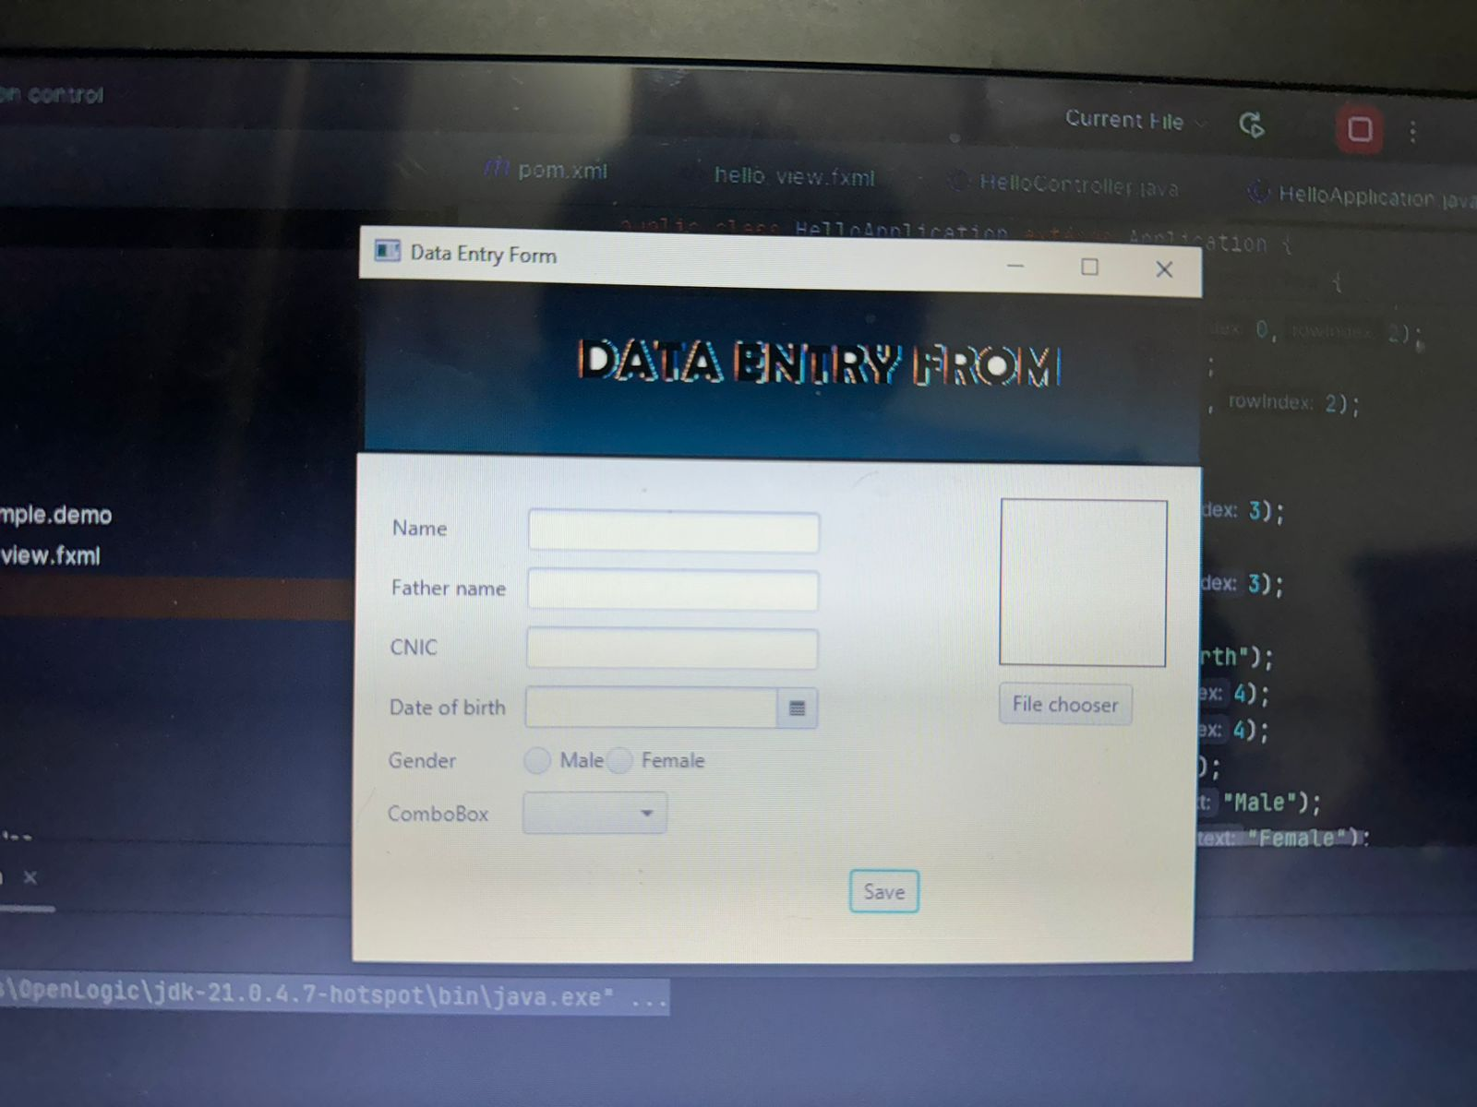

1. After Entering data in to the fields

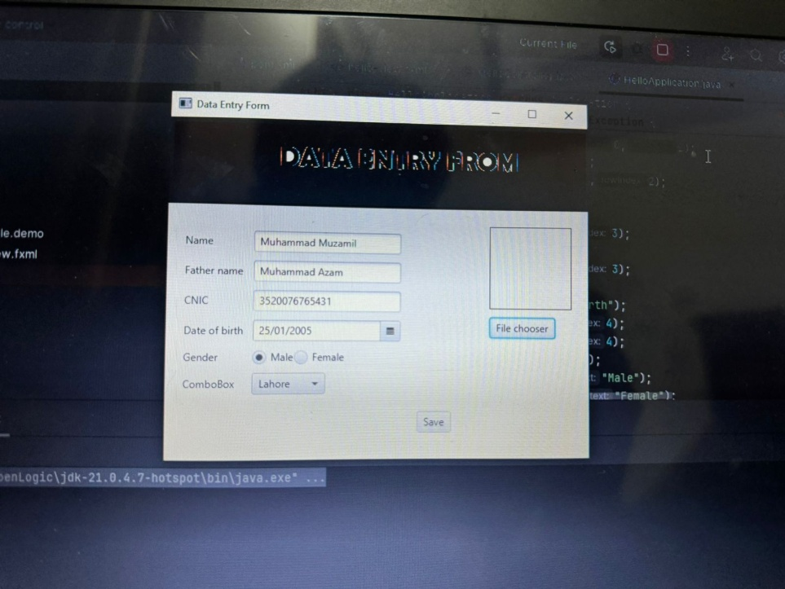

1. After selecting image from system using file chooser

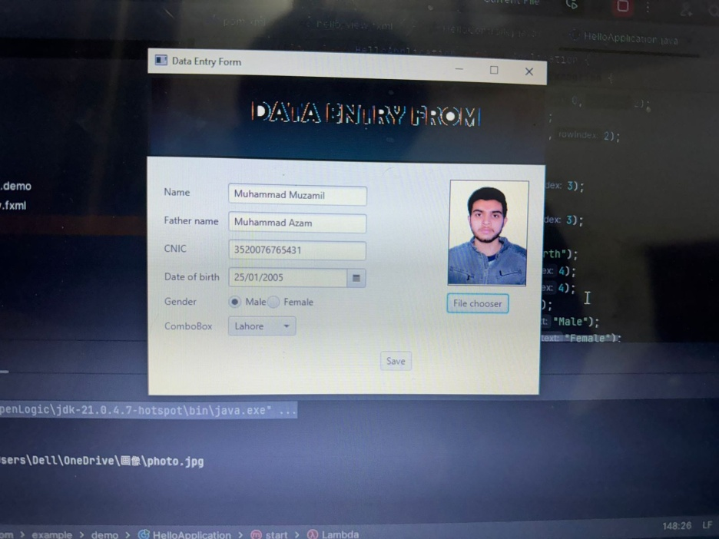

1. After click on save button saved the data in array and clear the form.

